Local Press Contact:
Jayne Feldman
BRAVE Public Relations
404.233.3993
jfeldman@emailbrave.com

**MEDIA ADVISORY/VISUAL OPPORTUNITY**
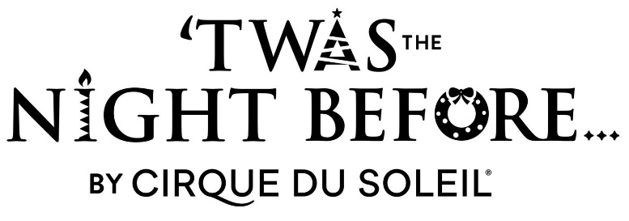

‘TWAS THE NIGHT BEFORE… by Cirque du Soleil – Final Rehearsals Ahead of Atlanta Premiere on Nov. 29
Media invited to capture photos/video of rehearsals for Cirque’s First Christmas Show, playing the Fox Theatre Nov. 29-Dec. 15
ATLANTA (Nov. 7, 2024) – Artists are preparing for the Atlanta premiere of the highly anticipated production of Cirque du Soleil’s ‘Twas the Night Before…, coming to Atlanta’s Fox Theatre for a limited two-week engagement starting Friday, Nov. 29 through Dec. 15 as part of the Regions Bank Broadway in Atlanta 2024/2025 season! On Wednesday, Nov. 27, media will have the opportunity to capture last-minute rehearsals of the show in progress on the Fox Theatre stage. In addition, cast and creatives will be available for interviews in the lobby.

WHAT: ‘Twas the Night Before… Media Day

WHEN: Wednesday, Nov. 27
Interviews with artists/artistic team available by appointment between 10-11:30 a.m. and 2-4 p.m.

WHERE: Fox Theatre
Media access will be provided upon RSVP
660 Peachtree St NE
Atlanta, GA 30308

HOW: This is a media-only event that is not open to the public. Interested media should confirm in advance with Jayne Feldman at jfeldman@emailbrave.com / 770.842.1424
###

